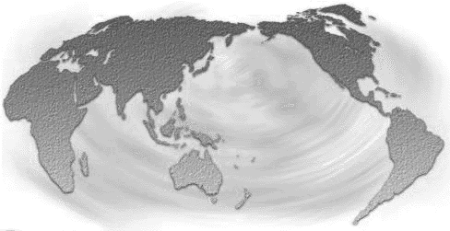
GLOBAL PEACE & JUSTICE AUCKLAND
Private Bag 68905, Newton, Auckland. www.gpja.pl.net

8 January 2006

Winston Peters
Minister of Foreign Affairs
Parliament Buildings

Wellington

Dear Mr Peters,

Assassination of Mr Joseph Pararajasingham

We hope you are aware of the assassination of Sri Lankan MP and human rights activist Joseph Pararajasingham as he attended a Catholic Church service in Sri Lanka on December 27th. Mr Pararajasingham was at the altar when the attack occurred.

Mr Pararajasingham visited New Zealand in May 2005 along with his fellow MP Mr Selvaraja Gajendran and met with GPJA supporters and human rights activists. He also met with several MP’s although I’m not sure if you were in that number.

Mr Pararajasingham was a Member of Parliament for Batticaloa in Sri Lanka for several years. His constituency is part of the Tamil community which has been involved in a long struggle for autonomy in Sri Lanka.

The assassination took place despite Mr Pararajasingham being under the military protection of the Sri Lankan government and was conducted by a paramilitary group – groups that have often been directly associated with the Sri Lankan government. Such groups have been used frequently to conduct a low-level campaign of violence and intimidation against Tamil community leaders and activists.

The grave danger following this assassination is that there will be a return to armed conflict in the struggle for Tamil independence. There is a peace process in place but it is in a fragile state.

GPJA supporters ask that the New Zealand government condemn the assassination and communicate this directly with the Sri Lankan government. It is imperative that pressure be mounted on the Sri Lankan government to reign in the para-military groups and negotiate in good faith through the peace process.

This is yet another conflict where the people of New Zealand can have an international impact beyond our size. We look forward to swift government action to contribute to justice and peace in Sri Lanka.

We look forward to hearing from you shortly.

Yours sincerely,

John Minto
For the GPJA Committee

