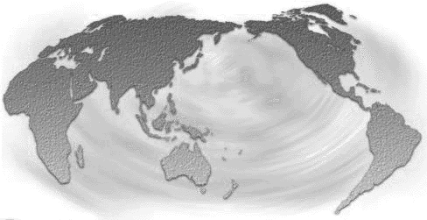
GLOBAL PEACE & JUSTICE AUCKLAND
Private Bag 68905, Newton, Auckland. www.gpja.pl.net

8 January 2006

Media Release:

Assassinated Sri Lankan MP Had Strong New Zealand Connections

Global Peace and Justice Auckland supporters were deeply shocked and saddened to learn of the assassination of Sri Lankan MP and human rights activist Joseph Pararajasingham as he attended a Catholic Church service in Sri Lanka on December 27th. Mr Pararajasingham was at the altar when the attack occurred.

Mr Pararajasingham visited New Zealand in May 2005 along with his fellow MP Mr Selvaraja Gajendran and met with GPJA supporters and human rights activists. The attached photo was taken after one of the meetings. (Mr Pararajasingham is the gentleman in the back with the yellow shirt and tie)

Mr Pararajasingham was a Member of Parliament for Batticaloa in Sri Lanka for several years. His constituency is part of the Tamil community which has been involved in a long struggle for autonomy in Sri Lanka.

The assassination took place despite Mr Pararajasingham being under the military protection of the Sri Lankan government and was conducted by a paramilitary group – groups that have often been directly associated with the Sri Lankan government. Such groups have been used frequently to conduct a low-level campaign of violence and intimidation against Tamil community leaders and activists.

The grave danger following this assassination is that there will be a return to armed conflict in the struggle for Tamil independence. There is a peace process in place but it is in a fragile state.

GPJA joins with the Tamil community in condemning the assassination and is calling on the New Zealand government to do likewise. We want the government to communicate directly with the Sri Lankan government – urging it to condemn the killing and vigorously pursue those responsible.

This is yet another conflict where the people of New Zealand can have an international impact beyond its size. We look forward to swift government action to contribute to justice and peace in Sri Lanka.

Mike Treen – (09) 3616989 or 0275254744
John Minto – (09) 8463173
Geraldene Peters - (09) 3765994

