FCE
PRESS RELEASE
BOOK LAUNCH - 21.02.2006

The Foundation for Co-Existence [FCE] is launching two books -‘Negotiating Peace in Sri Lanka: Efforts, Failures and Lessons Learnt’, Volume One and Volume Two- that document the history of peace negotiations and lessons learnt in Sri Lanka on the 21st of February 2006 from 5.00pm to 7.30pm at the Bandaranaike Memorial International Conference Hall, Committee Room B. This will be followed by a Symposium organized by the FCE on the 22nd and 23rd of February 2006 at the Moonstone Room, Ceylon Continental Hotel at 9.45 am.

Sri Lanka today faces a major challenge in resolving the armed conflict which has plagued it for many long years. If, ultimately, a solution to the country’s national question is to be found, it will be achieved through careful and often painful negotiations conducted by two sides, who have learned from their mistakes and pledged never to repeat them. The hope and belief of this will help facilitate that learning process by bringing together the considered views and experiences of many of those most closely involved in seeking a resolution to Sri Lanka’s troubles.

Volume One - ‘Negotiating Peace in Sri Lanka: Efforts, Failures and Lessons Learnt’ (Second Edition) edited by Dr. Kumar Rupesinghe and published originally in February 1998, offers an insightful and necessary examination of the past attempts to bring peace to Sri Lanka from 1985- 2000. The first volume is now being republished in a selective reprinting with the addition of several new chapters, concentrating specifically on the Kumaratunga era. It involves re arranging the original volume, which is divided into three sections, each encompassing a different phase of the peace process initiated by President Jayewardene, President Premadasa and President Chandrika Kumaratunga respectively. Volume One consists of articles by the following contributors: Jehan Perera, Jayadeva Uyangoda, Bradman Weerakoon, A.J .Chandrakanthan, Dayan Jayatilleke, J.N. Dixit, Bernard Tilakaratna, Ketheshwaran Loganathan, Sumanasiri Liyanage, Thomas Abraham, M.K.Narayanan, P.Rajanayagam, Rohan Gunaratna and Rajan Sriskandaraja

Volume Two - ‘Negotiating Peace in Sri Lanka: Efforts, Failures and Lessons Learnt’ (First Edition) of this publication is a series of papers focused solely on the UNF peace negotiations conducted from early 2002 to 2004. It attempts to capture an important phase in the peace negotiations when the Ceasefire Agreement was signed to restore normalcy after more than two decades of internecine war. The book concentrates solely on a discussion of the difficulties faced and the strategies adopted by the UNF and the LTTE to bring about a negotiated peace settlement. A group of eminent people who were closely involved in the negotiations process have contributed to this publication. Volume Two consists of articles and interviews by the following contributors: Kumar Rupesinghe, Bradman Weerakoon, Austin Fernando, G.L. Peiris, Priyan Seneviratna, Dinidu Endaragalle and Mahesan Selvaratnam, Dharmaratnam Sivaram, Gayathri Wickramasinghe, Saman Kelegama, Sunil Bastian, Sumanasiri Liyanage, K. Sivathamby, M.I.M. Mohideen, Keith Noyahr, N. Ram and Erik Solheim.

SYMPOSIUM -22 & 23.02.2006

PEACE NEGOTIATIONS IN SRI LANKA

Following the book launch FCE in its work towards peace building has organized a two days symposium on “Peace Negotiations in Sri Lanka” scheduled to start on the 22nd of February, 2006 at the Ceylon Continental Hotel to coincide with the 4th anniversary of the signing of the ceasefire agreement between the UNF and the LTTE. This will be held on the 22nd and 23rd of February at the Moonstone Room, Hotel Ceylon Continental at 9.45 am. The participants will be experts from Sri Lanka and Foreign Countries who have been working on Negotiation Peace Processes. They will be discussing, reviewing and sharing their knowledge and experiences on the past Peace Processes.

The Experts who will be contributing in this event are: Dr. Kumar Rupesinghe, Mr. Bradman Weerakoon – Secretary to the Former Prime Minster, Prof. Jayadeva Uyangoda – Head of Dept. – Political Science & History, University of Colombo, Prof. GL Peiris – Chief Negotiator of the UNF Peace Delegation, Mr.Dayan Jayathilleke – Adjunct Professor, Johns Hopkins University, Washington DC, Mr. Ed Garcia [Experiences from the Philippines], Senior Advisor for the Philippines & Colombia at International Alert, Prof Hizkias Assefa [Experiences from Sudan], Founder & Coordinator, African Peace building and Reconciliation Network, Mr. Vasu Gounden [Civil Society Perspective of the South African Negotiations], Founder & Chairman of the African Centre for the Constructive Resolution of Disputes, Ms. Olfat Hammad [Experiences from Palestine], Director Administration, Palestinian Centre for Policy and Survey Research, Dr Nobert Ropers, Executive Director, Berghof Centre for the Conflict Studies, Sri Lanaka Office.

This will provide an opportunity to undertake a systematic review of past peace processes and to learn from those lessons, On the basis of a summary of the lessons learnt, to articulate a strategy for future negotiation settlement

We would like to request for news coverage on this event. Please be kind enough to provide a good media coverage as this highlights the Peace Negotiation Process and also, will be a timely event.

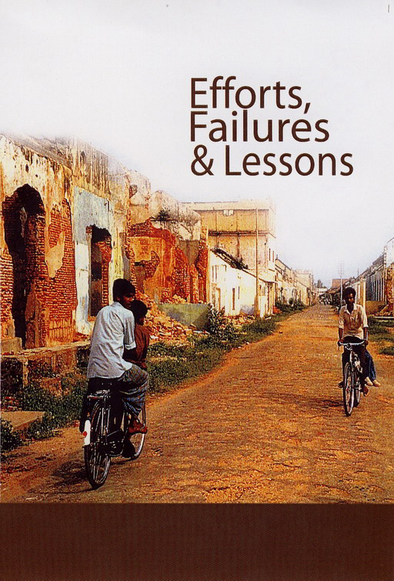
NEGOTIATING PEACE IN SRI LANKA: EFFORTS, FAILURES AND LESSONS LEARNT, VOLUME 1 – SECOND EDITION

VOLUME ONE edited by Dr. Kumar Rupesinghe and published originally in February 1998, offers an insightful and necessary examination of the past attempts to bring peace to Sri Lanka from 1985- 2000. The first volume is now being republished in a selective reprinting with the addition of several new chapters, concentrating specifically on the Kumaratunga era. It involves rearranging the original volume, which is divided into three sections, each encompassing a different phase of the peace process initiated by President Jayewardene, President Premadasa and President Chandrika Kumaratunga respectively.

Contents

- Acknowledgements

- Preface

- Introduction :
Negotiating Peace in Sri Lanka: Lessons from Peace Processes
Kumar Rupesinghe

1. Rereading Thimpu Principles:An integrative Perspective
Sumanasiri Liyanage and Nirupa Wickramasinghe

Contending Views on the Indo - Sri Lanka Accord :Third Party Intervention

2. The Emergence of the LTTE and the Indo-Sri Lanka Agreement of 1987
Thomas Abraham

3. Indian Involvement in Sri Lanka and the Indo-Sri Lanka Agreement of 1987:
A Retrospective Evaluation
J. N. Dixit

4. The Sri Lanka Government and Peace Efforts up to the Indo - Sri Lanka Accord:
Lessons and Experiences
Bernard Tilakaratne

5. Indo-Lanka Accord and the Ethnic Question:Lessons and Experiences
Ketheshwaran Loganathan

6. Role of Intelligence and Security Agencies
M. K. Narayanan

The Search for a Sri Lankan Solution: Premadasa - LTTE Talks

7. Government of Sri Lanka and LTTE Peace Negotiations 1989/90
Bradman Weerakoon

8. Negotiations between President Premadasa and the LTTE: A Retrospective
Assessment
A. J. V Chandrakanthan

9 . Premadasa - LTTE Talks: Why They Failed and What Really Happened
Dayan Jayatilleke

A Time for Hope and Despair: Kumaratunga - LTTE Negotiations

10. Govt. - LTTE Negotiations 1994 /1995 : Another Lost Opportunity
P. Rajanayagam

11. An Analysis of the Breakdown of Negotiations in the Sri Lankan Ethnic Conflict
Jehan Perera

12. Government-LTTE Negotiation Attempt of 2000 through Norwegian
Facilitation: Context, Complexities and Lessons
Jayadeva Uyangoda

Perspectives: Problems and Prospects

13. Impact of the Mobilized Tamil Diaspora on the Protracted Conflict in Sri Lanka
Rohan Gunaratna

14. MINDSET: The Foremost Obstacle to Peace
Rajan Sriskandarajah

Appendix

A.Letters Exchanged between the PA and the LTTE

B.Important Agreements Signed by the Sri Lankan State

C.Chronology of Events from 1985 -2001

D. The Contributors

E. Glossary of Abbreviations/Acronyms

NEGOTIATING PEACE IN SRI LANKA: EFFORTS, FAILURES AND LESSONS LEARNT, VOLUME 2

UNF- LTTE Negotiation

VOLUME TWO of this publication is a series of papers focused solely on the UNF peace negotiations conducted from early 2002 to 2004. It attempts to capture an important phase in the peace negotiations where the Ceasefire Agreement was signed to restore normalcy after more than two decades of internecine war. The book concentrates solely on a discussion of the difficulties faced and the strategies adopted by the UNF and the LTTE to bring about a negotiated peace settlement. A group of eminent people who were closely involved in the negotiations process have contributed to this publication in the form of articles and interviews. What is most significant about these two books is that most of it is written from an “insider’s” perspective which allows its authors to recount the experiences and lessons learnt in a candid manner.

CONTENTS

- Acknowledgements

- Preface

- Introduction
Kumar Rupesinghe

GoSL - LTTE Negotiations and the Security Dimension

- Evaluating the Peace Process
Kumar Rupesinghe

- Initiating and Sustaining the Peace Process: Origins and Challenges
Bradman Weerakoon

- The Peace Process and Security Issues
Austin Fernando

- The Ceasefire Agreement: Problems and Prospects
An interview with G.L. Peiris

- The Ceasefire Agreement: Violations, Violence and the Role of the SLMM
Priyan Seneviratna, Dinidu Endaragalle and Mahesan Selvaratnam

6. The Tamil Perspective
Dharmaratnam Sivaram

- Norwegian Facilitated Peace Talks
A Review of the Final Chapter of Anton Balasingham’s “War & Peace: Armed Struggle and Peace Efforts of Liberation Tigers”
Gayathri Wickramasinghe

The Humanitarian Response and the Peace Dividend
- Transformation of a Conflict via an Economic Dividend : The Sri Lankan Experience
Saman Kelegama

- How Development Undermined Peace
Sunil Bastian

- The Political Economy of Negotiating Peace in Sri Lanka: Lessons Learnt and Open Questions
Nicola Palmer

The Other Stakeholders and their Views
- Civil Society and the Peace Process
Sumanasiri Liyanage

12. Experiences and Fears: the Tamil Side of the Problem
K. Sivathamby with the assistance of S. Sothilingam

13. The Muslim Dimension and the Peace Process
M.I.M. Mohideen

The International Perspective
14. A Norwegian View
An Interview with Erik Solheim

15. The Role of the International Community
Keith Noyahr

Appendix
- Letters exchanged between the UNF & the LTTE
- Important agreements between the Sri Lankan state & the LTTE – the MoU of 2002, the ISGA and P-TOMS
- Peace Chronology - 2001 December onwards
- Bibliography

The Contributors

Glossary of Abbreviations/Acronyms

