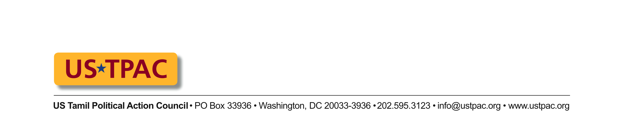
FOR IMMEDIATE RELEASE:

Washington, DC; August 12, 2009

Contact: USTPACinfo@gmail.com

Tamil Diaspora Organizations Meet US Assistant Secretary of State Robert Blake and Other State Dept. Officials to Discuss Humanitarian and Political Situation in Sri Lanka

Tamil Americans united under US Tamil Political Action Council (USTPAC), met yesterday with Assistant Secretary of State Robert Blake, and a number of other high ranking officials at the US State Department who cover Sri Lanka. The USTPAC delegation comprised of 16 Tamil Americans representing twelve different Tamil Diaspora organizations. US Chargé d’Affaires in Colombo, James Moore and US AID Mission Director Rebecca Cohn were joined by video conferencing. On the agenda was the humanitarian crisis for Tamils in Sri Lanka and prospects for political change in Sri Lanka.

The USTPAC delegates thanked Assistant Secretary Blake for the meeting and expressed their confidence in the newly confirmed Ambassador Patricia Butenis. The US is focusing on humanitarian aid for the IDPs interned in Vavuniya and elsewhere. Basic food is available to all, although variety in the diet remains a problem. Sanitation and health care are improving, but are not yet up to international standards. There are now 8 zones in Manik Farm as attempts are made to ease congestion.

6,000 to 9,000 IDPs have been released, mostly the elderly and the disabled. The US is advocating that other vulnerable populations also be released, along with those who have family to stay with. US Asst Secretary of State for Migration Eric Schwartz, who visited Sri Lanka as his first overseas trip in his new position, received information that 75,000 IDPs are to be released in August: 15,000 to Vavuniya, 25,000 to Kilinochchi and 35,000 to other areas (Jaffna, Batticaloa and Trincomalee).

During his visit, Asst Sec Schwartz was assured by the GoSL that their first priority is to resettle the Tamil IDP detainees. He visited all sectors of Manik Farm on a government-led tour. Other American officials have had the ability to tour the camps without military or government escorts. Journalists continue to have only limited access.

There are still many protection issues. Basic to protection is the registration of those interned in IDP camps. This registration is proceeding, with 125,000 being registered and in the process of receiving ID cards, 55% of the total, according to Chargé d'Affaires James Moore in the US Embassy in Colombo. Issues remain for the ICRC, which has not been a presence in the camps since early in July. Until that time they had some access to captured combatants. UNHCR is working on family reunification. UNHCR will not be taking over the camps, according to Asst Sec Blake, because Sri Lanka is a 'sovereign nation.'

The USTPAC raised the issue of the whereabouts of thousands of gravely injured Tamil civilians including children evacuated before the end of the military conflict, and reports of disappearances in the internment camps. The Dept. of State urged the Tamil Diaspora to provide them with names and date of birth of anyone who has disappeared to follow up on specific cases.

The US is emphasizing that return of IDPs does not have to wait for complete demining and has given $6.6 million to 4 demining INGOs, while urging the GoSL to come up with a comprehensive plan for demining, rather than current piecemeal efforts. The GoSL is holding bi-weekly meetings on demining, with a US representative always present. 15 villages in Mannar have been declared safe.

The US is encouraging the reintegration of former combatants and is giving $6 million for this effort, while looking for other donors for this effort. Sri Lanka’s Ministry of Justice under Milinda Maragoda is in charge of the rehabilitation effort.

On the continued imprisonment of the 5 doctors who courageously stayed behind and treated hundreds of war casualties, the US has no recent information, but believes that they remain at police headquarters in Colombo and will continue to bring up their case.

There is no conditioning of humanitarian aid by the US, but very comprehensive benchmarks toward improvement on issues to do with the IDPs, including access, registration, and resettlement have been established. Achievement of these confidential benchmarks over the next 3-6 months will determine whether development aid will be provided.

Asst Sec Blake said that the US is a strong supporter of devolution of power in Sri Lanka and a measure of autonomy for the Tamils in the areas they predominate. The Sri Lankan President's statement that a political solution would be looked into only after the presidential election in 2010 is disappointing, said Secretary Blake. Political reconciliation will signal the real end to the conflict. Devolution and reconciliation are factors in the benchmarks set up to assess progress. The State Dept. sees the Tamil diaspora as an important stakeholder for future reconciliation.

The State Dept asked USTPAC officials of their opinion about the Sri Lankan government’s expressed desire to engage Tamil diaspora in discussions. Tamil Americans expressed their apprehension on the true intentions of the GoSL in light of the abduction and illegal deportation of K. Pathmanathan, and similar threat to Diaspora leaders through Sri Lanka government organs. Asst Sec Blake said that even people in the US who may be affiliated with the LTTE, unless they break US laws by providing material assistance, will not be allowed to be prosecuted or persecuted by Sri Lankan authorities.

The assembled Tamil American organizations asked many questions concerning US policy and actions toward the crisis for the Tamils in Sri Lanka. Their concerns based on information received from friends, family and other sources, especially concerning the situation at the internment camps, resettlement, the continued militarization of the NorthEast, disappearances and torture, colonization of Tamil areas, the use of development aid for the subjugation of the NorthEast, the appropriation of the resources of the NorthEast by outsiders and hopes for political change were addressed at the meeting. The Assistant Secretary expressed his desire to continue the discussions with Tamil Americans in the near future.

